Assignment 2

SUNKARA NAGA DHANUNJAY

116CS0181

1) IP Address : 192.168.43.169

MAC Address : 6c:3b:e5:29:f6:17

Subnet Address : 255.255.252.0

Gateway Address : 192.168.40.1

2) When Changing first,second,third,fourth subfield of IP Address

Command :

sudo ifconfig eth0 192.168.41.169 netmask 255.255.255.0

Result :

By using the following command the ip address can be changed but it is not reflected in connection information. Moreover, internet access is blocked. Once I disabled enable networking option and enabled it the ip address is set to one that used to be there before the change was made.

3) Changing MAC Address :

Command : sudo ifconfig eth0 hw ether 02:01:02:03:04:08

Previous MAC Address : 6c:3b:e5:29:f6:17

Changed MAC Address : 02:01:02:03:04:08

After disabling networking option and reenabling it MAC address is changed back to 6c:3b:e5:29:f6:17.

4) Ping Gateway

Command : ping 192.168.40.1

sw2@sw2-OptiPlex-9020:~$ ping 192.168.40.1

PING 192.168.40.1 (192.168.40.1) 56(84) bytes of data.

64 bytes from 192.168.40.1: icmp_seq=1 ttl=64 time=0.284 ms

64 bytes from 192.168.40.1: icmp_seq=2 ttl=64 time=2.35 ms

64 bytes from 192.168.40.1: icmp_seq=3 ttl=64 time=0.281 ms

64 bytes from 192.168.40.1: icmp_seq=4 ttl=64 time=0.621 ms

64 bytes from 192.168.40.1: icmp_seq=5 ttl=64 time=0.283 ms

64 bytes from 192.168.40.1: icmp_seq=6 ttl=64 time=0.295 ms

64 bytes from 192.168.40.1: icmp_seq=7 ttl=64 time=0.262 ms

^C

--- 192.168.40.1 ping statistics ---

7 packets transmitted, 7 received, 0% packet loss, time 5998ms

rtt min/avg/max/mdev = 0.262/0.625/2.352/0.714 ms

sw2@sw2-OptiPlex-9020:~$

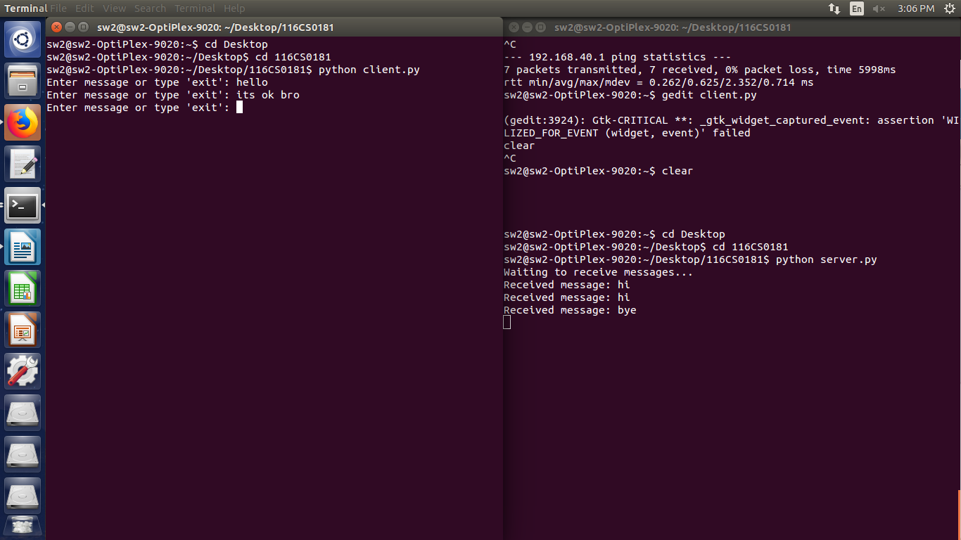5)

Port address used : 8888

6) Changing port address from 8888 to 8080 in one of the system.

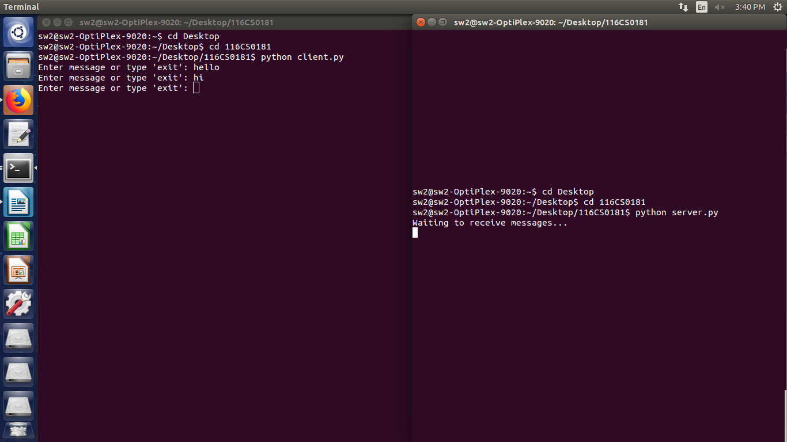

While port address is not same in both systems the messages typed in client program of one computer will not get received in server program of other computer and viceversa.

7) Testing network connectivity by loop back address

Command : ping 127.0.0.1

Result :

sw2@sw2-OptiPlex-9020:~$ ping 127.0.0.1

PING 127.0.0.1 (127.0.0.1) 56(84) bytes of data.

64 bytes from 127.0.0.1: icmp_seq=1 ttl=64 time=0.025 ms

64 bytes from 127.0.0.1: icmp_seq=2 ttl=64 time=0.027 ms

64 bytes from 127.0.0.1: icmp_seq=3 ttl=64 time=0.026 ms

64 bytes from 127.0.0.1: icmp_seq=4 ttl=64 time=0.028 ms

64 bytes from 127.0.0.1: icmp_seq=5 ttl=64 time=0.030 ms

64 bytes from 127.0.0.1: icmp_seq=6 ttl=64 time=0.030 ms

64 bytes from 127.0.0.1: icmp_seq=7 ttl=64 time=0.033 ms

64 bytes from 127.0.0.1: icmp_seq=8 ttl=64 time=0.029 ms

^C

--- 127.0.0.1 ping statistics ---

8 packets transmitted, 8 received, 0% packet loss, time 6996ms

rtt min/avg/max/mdev = 0.025/0.028/0.033/0.005 ms

sw2@sw2-OptiPlex-9020:~$

8) BW of our network

1000 Mb/s